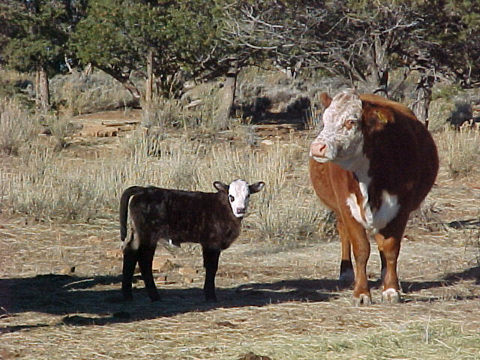 Our cows are mostly Black Angus and Murray Grays, though we have the occasional exception like this Hereford above and her half Angus calf. One thing’s for sure, they’re fairly happy. Every spring brings new members to the herd. Our natural grass fed beef is raised without the use of chemical parasiticides, fertilizers, or hormones.

